

To whom it may concern,

It is my pleasure to recommend Xiaoqin Feng for admission to your esteemed M.S. program in Computer Science, specializing in Artificial Intelligence. Over the past five years as her work advisor, I have witnessed her remarkable growth, particularly in research, product development, and leadership.

During her time with our team, Xiaoqin has made significant contributions to our speech synthesis department, assuming multiple critical roles as a researcher, engineer, and team leader. As a researcher and engineer, she developed innovative algorithms and optimizations for tokenization, text normalization, and prosody, which have greatly enhanced the performance of our text-to-speech system. Notably, I remember she took more effort into our polyphone prediction, which was her start project, and she completed it perfectly. Her passion for advancing technology and her dedication to staying abreast of the latest research are evident in her frequent, insightful contributions to our team’s discussions. Her work has been recognized through several impactful publications and patents, underscoring her technical expertise and collaborative spirit. For instance, she published several papers in PRML 2022, APSIPA 2023 and APIN 2024, in collaboration with me and her interns. I regard her as one of the best “worker” and “researcher” in my career life, as she covers patience, responsibility, and intelligence.

Xiaoqin has also proven to be an outstanding leader. She has successfully led both our evaluation team and the voice team, developing an industry-leading evaluation system that has provided valuable technical insights for our algorithms and products. Most notably, she spearheaded the formation of an advanced data team and established a comprehensive data pipeline, a critical foundation for our large language model research. In her role as head of the voice team, she expertly managed engineering, algorithm development, and product planning, driving significant value and revenue for the company.

I am confident that Xiaoqin’s innovative thinking, persistence in machine learning research, and her well-rounded skill set would make her an invaluable asset to your M.S. program. I highly recommend her for your favorable consideration. Please feel free to contact me if you have any further questions.

Thank you for your time and consideration.

Yours Sincerely,

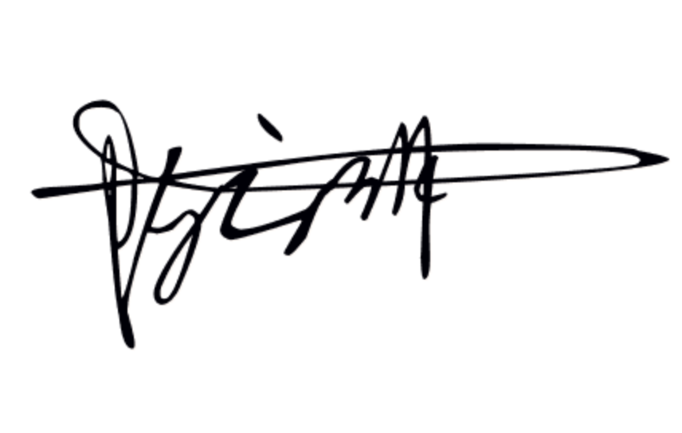

Yunlin Chen

Technical Director at Mobvoi AI Lab.

yunlinchen@mobvoi.com

https://scholar.google.com/citations?user=VR-gvoIAAAAJ&hl=en

Mobvoi Corporation | Ronghui, Haidian, Beijing, 100000, China